YN  BRIEF  You have been asked to research, design and develop prototypes of modular housing that will be used for new towns and villages being built over the country. The aim will be supporting families in modern, affordable, energy efficient homes.  Examples  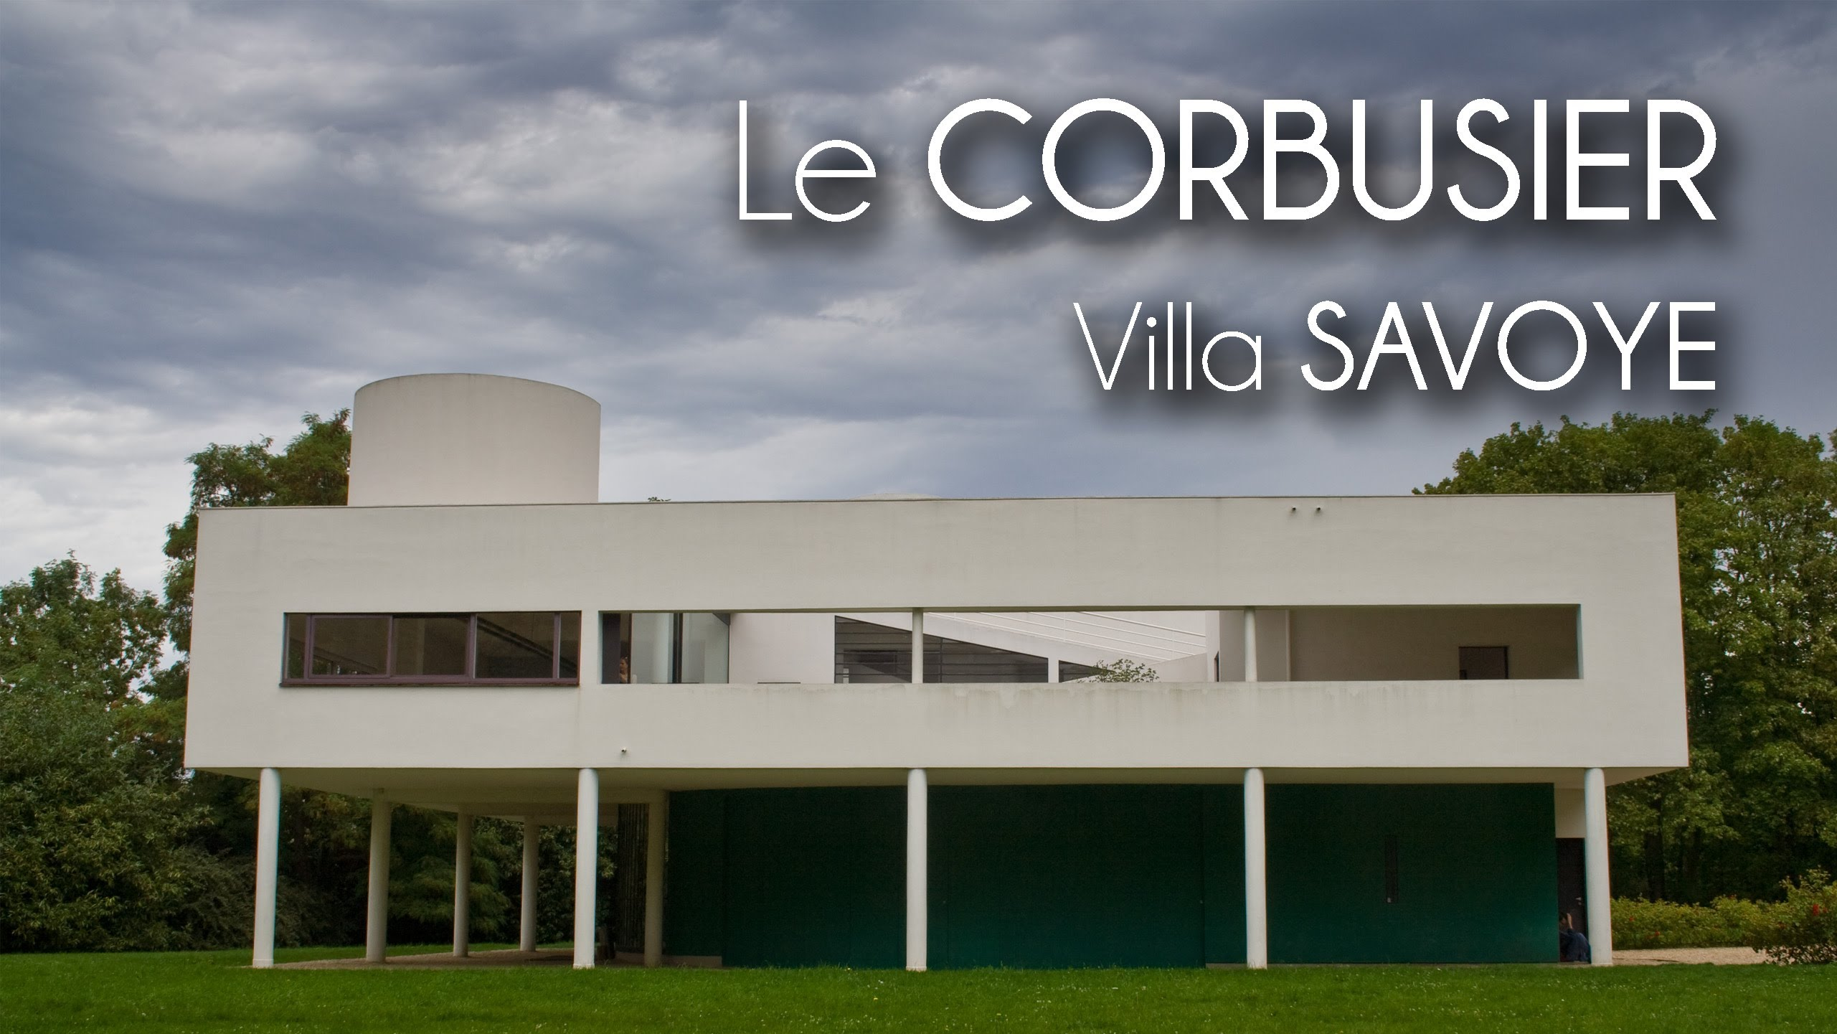  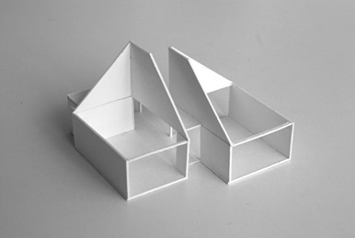 | Concept Housing  SPECIFICATION  This is your success criteria: •  - It must have several zones – Kitchen, living/communal room, Sleeping areas, Bathrooms  - It must be practical for a range of groups – families, children, elderly  - It must be constructed using SIP (Structured insulated panels)  - It should be energy efficient  - It should use modern technologies and materials  - It should be made suing sustainable materials  - It should be visually creative  - It could be possible for the building to link together  - It could incorporate renewable energy resources  - It could have several floors  TASKS  What you will need to do over the day:  1a - Research: Materials and Energy  1b - Company branding & logo development  2a - Concept designs – 2d Drawing & 3d Drawing (Profile, 2 point  perspective and isometric)  2b - Floor plans and side/section/layout drawings  3a - CAD training with Google Sketch up  3b - CAD Design developments (Google Sketch up)  4a – Modelling prototypes with card  4b - SIP Design – CAD/CAM using 2D design.  End of the day: Final Presentation of Ideas and Judging of the winners  The final winning designs will be made in plastic and presented to each of the winners – A large model will then be on display in school

Technology

What are Photo-voltaic cells? http://www.energysavingtrust.org.uk/renewable-energy/electricity/solar-panels

Are they worth the initial cost? How long do they currently take to pay for themselves, Should they be used in your build and why?

What is a MHVR unit? How can it make homes more energy efficient?

How can Geothermal energy be used in your housing development?

Building materials
What are Structural insulated panels (SIPS)? https://www.homebuilding.co.uk/sips-how-do-they-work/

Why are they a sustainable way of building houses?

How can you make a house energy efficient?

What other types of building materials are sustainable?

What materials have a low carbon footprint?

What are the advantages and disadvantage of using sustainable materials?

Final Logo
Company name ideas
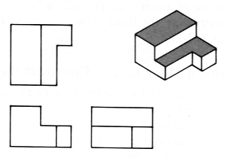
Side view
Front view
Plan view
Final Orthographic design

